Supplemental Information
Table S1: Reporting template for tabulating essential SAS data acquisition, sample details, data analysis, modelling fitting and software used.
SAXS data collection parameters
Instrumentation with reference for data acquisition and processing details.
wavelength
Beam geometry
q-measurement range (Å⁻¹ or nm⁻¹)
Absolute scaling method
Exposure time (seconds or minutes)
Sample configuration
Sample temperature (ºC)
Sample details
 | Sample 1 | Sample 2 | Sample 3, etc
Source
Sample description: sequence (including tags) + bound ligands/modifications, etc
Extinction coefficient (A280, 0.1% solution) and method of determination
Concentration (range) mg/mL, or SEC loading concentration, volume and flow rate
M_{r} from sequence
Solvent details
Partial specific volume from sequence ($ϑ$ cm³ g⁻¹)
Particle contrast from sequence and solvent constituents (Δρ, 10¹⁰ cm⁻²)
Guinier analysis
I(0) (cm⁻¹) normalised to unit concentration (w/v)
R_{g} (Å or nm)
qR_{g} range (Å⁻¹ or nm⁻¹)
Quality-of-fit parameter (with definition)
M_{r} from I(0) (ratio to expected value from sequence)^{b}
P(r) analysis
I(0) (cm⁻¹) normalised to unit concentration (w/v)
R_{g} (Å or nm)
d_{max} (Å or nm)
q range (Å⁻¹ or nm⁻¹)
Quality-of-fit parameter (with definition)
M_{r} from I(0) (ratio to expected value from sequence)
V_{P} (Å⁻³ or nm⁻³) and any constant adjustment to background
Model fitting results (a complete panel for each method)
q range for fitting (Å⁻¹ or nm⁻¹)
Symmetry assumptions
Ambiguity measure(s) with definitions
Model(s) precision
χ² range value/range
Adjustable parameters in the model fit
Volume/M_{r} estimate for shape models (Å⁻³ or nm⁻³)
R_{g} values (Å or nm) and relative phase volumes (Å⁻³ or nm⁻³) for multiple phase shape models
Domain/subunit contacts and regions of presumed flexibility for atomistic modelling
Software employed for SAXS data reduction, analysis and interpretation
SAXS data reduction to sample minus solvent, including desmearing, extrapolation, merging, etc as relevant
Intensity scaling method
Calculation of extinction coefficient from sequence
Calculation of Δρ and $ϑ$ values from sequence
Basic analyses: Guinier, P(r), Porod volume
Shape/bead modelling
Atomic structure modelling (rigid body, ensemble)
3D graphic model representations

Table S2: CRYSOL parameters for fits to GI, BSA, and CaM showing variability in adjustable parameters Ra and Dro with and without a constant adjustment to force q⁻⁴ dependence at high q
Protein | χ² | R_{g} | Ra | Dro | Constant adjustment to intensity | Average electron density
CaM | 21.77 | 22.83 | 1.40 | 0.015 | Yes | 0.4149
 | 23.95 | 23.14 | 1.40 | 0.045 | No | 0.4707
BSA | 1.980 | 28.01 | 1.46 | 0.037 | Yes | 0.4633
 | 4.120 | 27.86 | 1.80 | 0.033 | No | 0.4583
GI | 1.003 | 32.74 | 1.42 | 0.130 | Yes | 0.4055
 | 1.027 | 32.71 | 1.70 | 0.130 | No | 0.4017

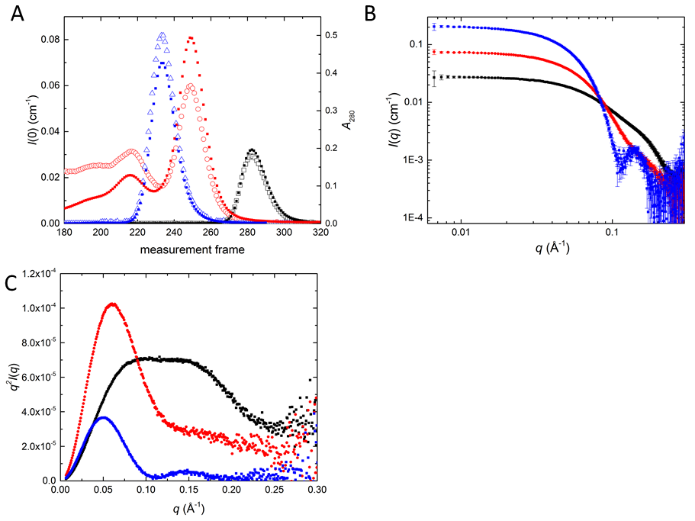

Figure S1: A. Overlaid plots of I(0) (solid symbols) and A280 (open symbols) as a function of time/measurement frame showing the good correspondence in peak shape that facilitates concentration estimates for a set of measurement frames. B. logI(q) v logq plots showing the expected zero slope at low-q expected for monodisperse scattering particles of similar size. C. Kratky plots for GI, BSA, and CaM. The rising Kratky plot for q values > 0.25 Å⁻¹ for BSA and CaM are indicative of flexibility in these proteins. Color code is as in main figures: GI (blue), CaM (black) and BSA (red).

